2021 SUPER BOWL CHALLENGE

Rules - Answer questions and receive points if correct.
Player with most points wins.

- Who will win the Super Bowl?
  - Tampa Bay Buccaneers = 35
  - Kansas City Chiefs = 29
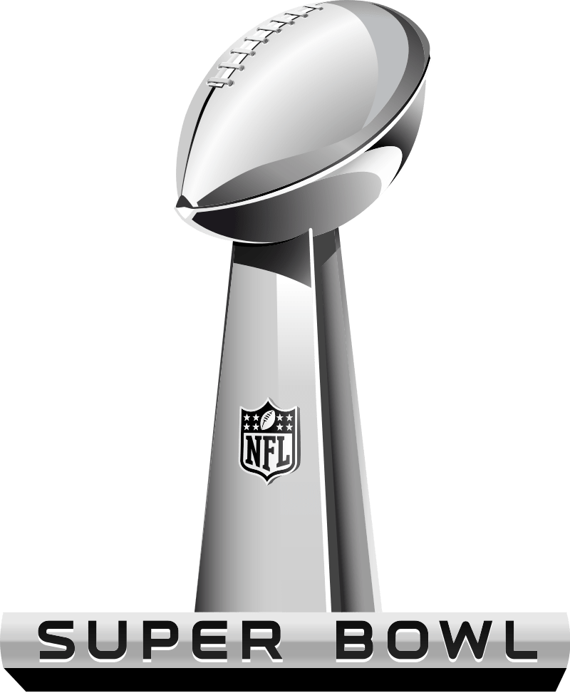
- Total points scored in the Super Bowl?
  - Over 56.5 = 30
  - Under 56.5 = 30

- Who will be ahead at half-time?
  - Tampa Bay = 22
  - Kansas City = 20
  - Tied at Half = 33

- Coin Toss?
  - Heads = 11
  - Tails = 11

- Will there be a missed extra point?
  - Yes = 13
  - No = 7

- Who will commit first penalty?
  - Tampa Bay = 11
  - Kansas City = 11

- Team to get the first points of the game?
  - Tampa Bay = 15
  - Kansas City = 14

- Which team will get to 10 points first?
  - Tampa Bay = 15
  - Kansas City = 13

- Will Tom Brady (TB) run in a TD?
  - Yes = 13
  - No = 5

- First penalty of the game will be?
  - Holding = 8
  - False Start = 8
  - Pass Interference = 13
  - Anything but the 3 mentioned above = 5

- Player to score 1st TD?
  - Field (any player not listed below) = 20
  - Clyde Edwards-Helaire (KC) = 17
  - Darrel Williams (KC) = 17
  - Sammy Watkins (KC) = 28
  - Tyreek Hill (KC) = 12
  - Travis Kelce (KC) = 12
  - Demarcus Robinson (KC) = 33
  - Mecole Hardman (KC) = 25
  - Patrick Mahomes (KC) = 18
  - Leonard Fournette (TB) = 15
  - Ronald Jones (TB) = 16
  - Mike Evans (TB) = 17
  - Chris Godwin (TB) = 16
  - Rob Gronkowski (TB) = 18
  - Antonio Brown (TB) = 18
  - Scotty Miller (TB) = 25
  - Cameron Brate (TB) = 25
  - Tom Brady (TB) = 22
  - No TD’s scored in game = 100

- Player to score 2nd TD?
  - Field (any player not listed below) = 20
  - Clyde Edwards-Helaire (KC) = 17
  - Darrel Williams (KC) = 17
  - Sammy Watkins (KC) = 28
  - Tyreek Hill (KC) = 12
  - Travis Kelce (KC) = 12
  - Demarcus Robinson (KC) = 33
  - Mecole Hardman (KC) = 25
  - Patrick Mahomes (KC) = 18
  - Leonard Fournette (TB) = 15
  - Ronald Jones (TB) = 16
  - Mike Evans (TB) = 17
  - Chris Godwin (TB) = 16
  - Rob Gronkowski (TB) = 18
  - Antonio Brown (TB) = 18
  - Scotty Miller (TB) = 25
  - Cameron Brate (TB) = 25
  - Tom Brady (TB) = 22
  - Less than 2 TD’s scored in the game = 50

- Player to score 1st TD in the second half?
  - Field (any player not listed below) = 20
  - Clyde Edwards-Helaire (KC) = 17
  - Darrel Williams (KC) = 17
  - Sammy Watkins (KC) = 28
  - Tyreek Hill (KC) = 12
  - Travis Kelce (KC) = 12
  - Demarcus Robinson (KC) = 33
  - Mecole Hardman (KC) = 25
  - Patrick Mahomes (KC) = 18
  - Leonard Fournette (TB) = 15
  - Ronald Jones (TB) = 16
  - Mike Evans (TB) = 17
  - Chris Godwin (TB) = 16
  - Rob Gronkowski (TB) = 18
  - Antonio Brown (TB) = 18
  - Scotty Miller (TB) = 25
  - Cameron Brate (TB) = 25
  - Tom Brady (TB) = 22
  - No TD’s scored in the 2nd half = 25

- 1st points scored in game?
  - Field Goal = 15
  - Rushing TD = 15
  - Receiving TD = 15
  - Defensive TD = 30
  - Kickoff or punt return TD = 30
  - Safety = 50

- 2nd points scored in game?
  - Field Goal = 15
  - Rushing TD = 15
  - Receiving TD = 15
  - Defensive TD = 30
  - Kickoff or punt return TD = 30
  - Safety = 50

- 1st points scored in second half?
  - Field Goal = 15
  - Rushing TD = 15
  - Receiving TD = 15
  - Defensive TD = 30
  - Kickoff or punt return TD = 30
  - Safety = 50

- Highest scoring quarter (excludes OT)?
  - 1st quarter = 13
  - 2nd quarter = 11
  - 3rd quarter = 13
  - 4th quarter = 11
  - Tie (2 quarters or more tie for highest) = 9

- Shortest TD of the game?
  - Over 1.5 = 12
  - Under 1.5 = 12

- Will there be a score of any kind when the clock hits :59 seconds (or less) in the first half?
  - Yes = 15
  - No = 15

- Will there be a score of any kind in the first 5:00 of 2nd half (10:00 or more on the clock for yes)?
  - Yes = 15
  - No = 12

- 1st kickoff of the second half will be?
  - Touchback = 5
  - Anything but a touchback = 12

- Who will have more on Super Bowl Sunday?
  - Tom Brady (TB) TD Passes + Interceptions (NFL) = 13
  - Minnesota Wild Goals (NHL) Super Bowl Sunday = 14

- Who will have more on Super Bowl Sunday?
  - Tyreek Hill (KC) receiving yards (NFL) = 18
  - Utah Jazz total points scored (NBA) Super Bowl Sunday = 15

- Who will have more on Super Bowl Sunday?
  - Kansas City points scored (NFL) = 16
  - Paul George (LAC) points scored + rebounds (NBA) = 15

- What will be higher on Super Bowl Sunday?
  - Travis Kelce (KC) receiving yards (NFL) = 17
  - Total points scored between Georgetown and Villanova (NCAAM) = 15

- Who will be more on Super Bowl Sunday?
  - Shortest Field Goal made in the Super Bowl (NFL) = 18
  - Giannis Antetokounmpo (MIL) points (NBA, Saturday 2/6 game) = 17

- What will be higher on Super Bowl Sunday?
  - Tom Brady (TB) longest completion (NFL) = 20
  - Jaylen Brown (BOS) points + rebounds (NBA) = 20

- Who will have more receiving yards?
  - Mecole Hardman + Sammy Watkins (KC) = 18
  - Mike Evans + Tyler Johnson (TB) = 18

- What will be higher on Super Bowl Sunday?
  - Points by Kansas City (KC) = 18
  - Highest win payoff at Santa Anita for $2 (Horse Racing) = 18

- Total sacks in the Super Bowl both teams combined?
  - Over 4.5 (NFL) = 18
  - Under 4.5 (NFL) = 17

- Patrick Mahomes (KC) total passing yards?
  - Over 329.5 = 18
  - Under 329.5 = 18

- Patrick Mahomes (KC) TD passes?
  - Over 2.5 = 13
  - Under 2.5 = 17

- Tom Brady (TB) total passing yards?
  - Over 300.5 = 18
  - Under 300.5 = 18

- Tom Brady (TB) TD passes?
  - Over 2.5 = 15
  - Under 2.5 = 15

- Who will throw the first TD pass – Patrick Mahomes (KC) or Tom Brady (KC)?
  - Patrick Mahomes = 15
  - Tom Brady = 18
  - Neither will throw a TD pass = 40

- Receiving Yards by Tyreek Hill (KC)?
  - Over 102.5 = 15
  - Under 102.5 = 15

- Will the game ever be tied again after 0-0?
  - Yes = 18
  - No = 15

- Number of players to attempt a pass?
  - Over 2.5 = 15
  - Under 2.5 = 11

- Will there be a TD in all 4 quarters (OT not included)?
  - Yes = 15
  - No = 15

- Longest Field Goal?
  - Over 41.5 = 20
  - Under 41.5 = 20
  - No Field Goal = 40

- Will there be a kick return or defensive interception/fumble return for a TD?
  - Yes = 25
  - No = 10

- Will there be a 50 yard (or more) Field Goal made?
  - Yes = 15
  - No = 13

- Will an onside kick attempted?
  - Yes = 12
  - No = 10

- Will an onside kick be recovered by either team (kicking team recovers)?
  - Yes = 30
  - No = 5

- Super Bowl MVP? (If shared MVP, each wins the points listed)
  - Field (anyone other than listed below) = 25
  - Patrick Mahomes (KC) = 10
  - Tom Brady (TB) = 13
  - Travis Kelce (KC) = 18
  - Tyreek Hill (KC) = 20
  - Leonard Fournette (TB) = 35
  - Antonio Brown (TB) = 50
  - Mike Evans (TB) = 50
  - Chris Godwin (TB) = 50

- Will there be a successful two-point conversion?
  - Yes = 17
  - No = 17

- Will Super Bowl margin of difference be 7 or less when clock hits 59 seconds remaining in game?
  - Yes = 17
  - No = 16

- Will Super Bowl margin of difference be 3 or less when clock hits 59 seconds remaining in game?
  - Yes = 20
  - No = 14

- Will the margin of victory (by either team) be exactly 3 points?
  - Yes = 16
  - No = 8

- Last play of the game will be a QB kneel-down?
  - Yes = 15
  - No = 15

